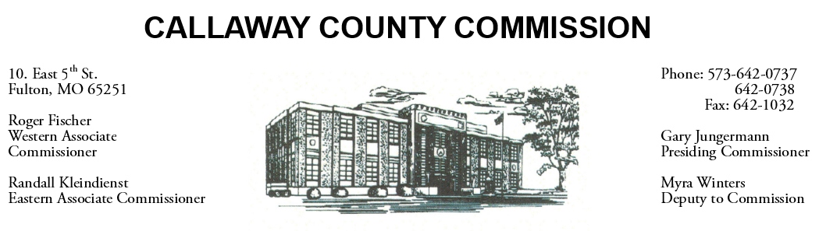

April 16, 2019
Tuesday
Tentative Agenda

- The Callaway County Commission will meet with Abigail Horton, Maddy Brown and Margie Hoskins of William Woods University to discuss Rice Hall … 1:00 p.m.
- The Callaway County Commission will meet with Jennifer Wilson of N-Form Architecture ………………………………………………………………. 2:00 p.m.

Discuss and possibly sign purchase orders and requisitions submitted by elected
officials. Sign off on previous meeting minutes. The above meetings will be held
in the Commission Chambers, Courthouse, Fulton, Mo

(Unless otherwise stated)

Notice posted: 04/15/19_______at_8:30a.m.

