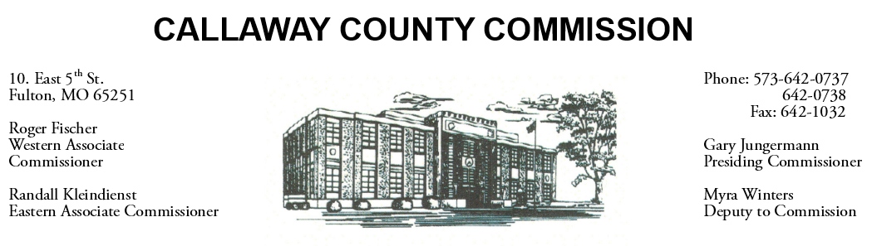

May 16, 2019
Thursday
Tentative Agenda

- The Callaway County Commission may attend the FEMA Emergency Prep Class at Callaway Electric from 8:00 a.m. until 12:00 p.m.

Discuss and possibly sign purchase orders and requisitions submitted by elected
officials. Sign off on previous meeting minutes. The above meetings will be held
in the Commission Chambers, Courthouse, Fulton, Mo

(Unless otherwise stated)

Notice posted: 05/15/19_______at_8:30a.m.

