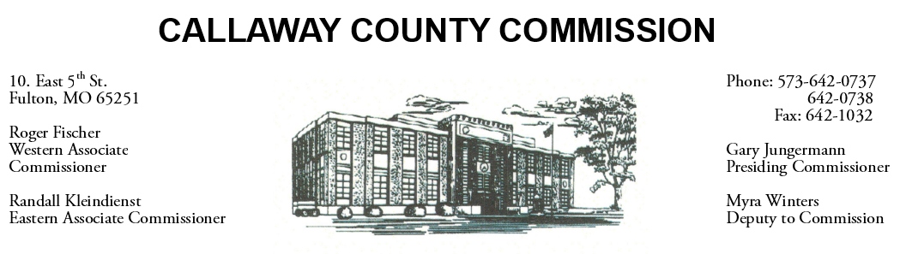

June 13, 2019
Thursday
Tentative Agenda

- The Callaway County Commission may attend a 200 committee meeting at the Callaway Chamber of Commerce ……………………………………….... 9:00 a.m.
- The Callaway County Commission may attend the Callaway Chamber of Commerce new member reception at the Callaway Chamber of Commerce office ....... 4:00 p.m.

Discuss and possibly sign purchase orders and requisitions submitted by elected
officials. Sign off on previous meeting minutes. The above meetings will be held
in the Commission Chambers, Courthouse, Fulton, Mo

(Unless otherwise stated)

Notice posted: 06/12/19_______at_8:30a.m.

