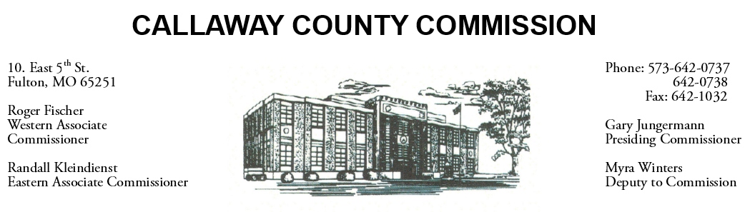

August 13, 2019
Tuesday
Tentative Agenda

- The Callaway County Commission will attend a graded nuclear drill at the EOC (Emergency Operations Center) ……………………………………….. 8:00 a.m.
- The Callaway County Commission will meet with Paul Winkelmann to award Bid #20 (Asphalt Paving Projects) and to discuss the FLAP grant (Cedar Creek Bridge)……………………….…………………..……………………… 2:00 p.m.

Discuss and possibly sign purchase orders and requisitions submitted by elected
officials. Sign off on previous meeting minutes. The above meetings will be held
in the Commission Chambers, Courthouse, Fulton, Mo

(Unless otherwise stated)

Notice posted: 08/12/19_______at_1:48 p.m.

