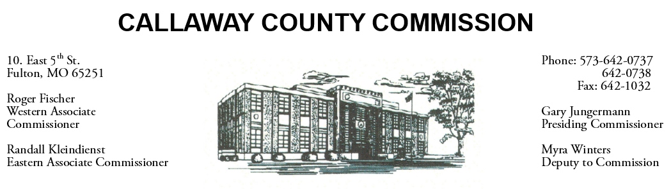

September 12, 2019
Thursday
Tentative Agenda

- The Callaway County Commission will attend the Rock Barn Antiques event ……………………………………………………………………………... 9:00 a.m.
- The Callaway County Commission will meet with Cindy Garrett to discuss an MOU with Power House Community Development Corp. ……………………… 1:15 p.m.
- The Callaway County Commission will attend the Holts Summit City and Business meeting in Holts Summit, MO…………………………………..…….…. 4:30 p.m.

Discuss and possibly sign purchase orders and requisitions submitted by elected
officials. Sign off on previous meeting minutes. The above meetings will be held
in the Commission Chambers, Courthouse, Fulton, Mo

(Unless otherwise stated)

Notice posted: 09/11/19_______at_8:30a.m.

