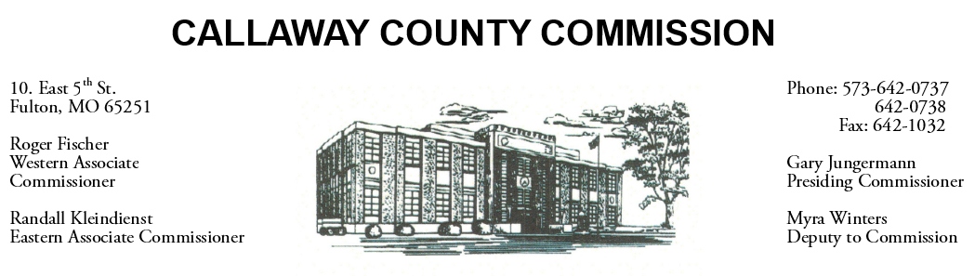

September 11, 2019
Wednesday
Tentative Agenda

- The Callaway County Commission will attend the HarbisonWalker International ribbon cutting ceremony ………………………………………………… 8:00 a.m.

Discuss and possibly sign purchase orders and requisitions submitted by elected
officials. Sign off on previous meeting minutes. The above meetings will be held
in the Commission Chambers, Courthouse, Fulton, Mo

(Unless otherwise stated)

Notice posted: 09/10/19_______at_8:30a.m.

