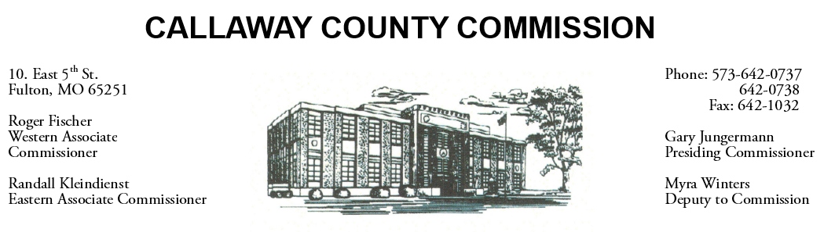

November 11, 2019
Monday
Tentative Agenda

- The Callaway County Courthouse will be closed in observance of Veterans day.

November 12, 2019
Tuesday
Tentative Agenda

- The Callaway County Commission will have budget discussions throughout the day.
- The Callaway County Commission will conduct business of a general nature.

Discuss and possibly sign purchase orders and requisitions submitted by elected
officials. Sign off on previous meeting minutes. The above meetings will be held
in the Commission Chambers, Courthouse, Fulton, Mo

(Unless otherwise stated)

Notice posted: 11/08/19_______at_08:30 a.m.

