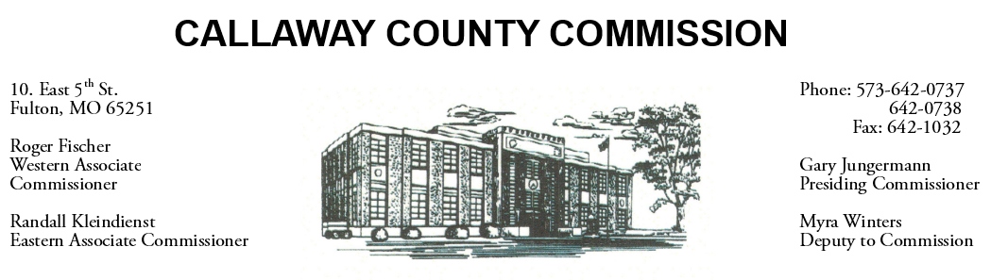

December 03, 2019
Tuesday
Tentative Agenda

- The Callaway County Commission will have budget discussions throughout the day.
- The Callaway County Commission will meet to discuss the 2020 holiday dates…………………………………………..………………………….. 11:30 a.m.
- The Callaway County Commission may attend the Central Bank Holiday open house in Jefferson City, MO ……………………………………………… 4:30 p.m.
- The Callaway County Commission may attend the Callaway Chamber of Commerce Business Afterhours event at the Fulton Country Club ………..…………. 5:00 p.m.

Discuss and possibly sign purchase orders and requisitions submitted by elected
officials. Sign off on previous meeting minutes. The above meetings will be held
in the Commission Chambers, Courthouse, Fulton, Mo

(Unless otherwise stated)

Notice posted: 12/02/19___at_08:30 a.m.

