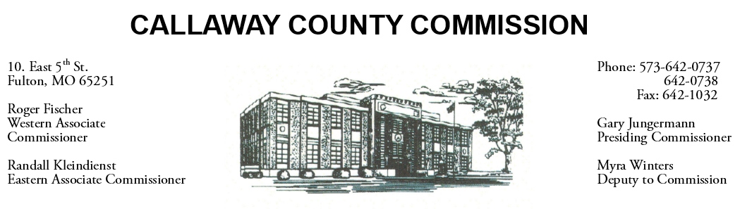

January 14, 2020
Tuesday
Tentative Agenda

- The Callaway County Commission will meet to discuss Public Administrator software …………………………………..………………………. 10:30 a.m. Canceled

Discuss and possibly sign purchase orders and requisitions submitted by elected
officials. Sign off on previous meeting minutes. The above meetings will be held
in the Commission Chambers, Courthouse, Fulton, Mo

(Unless otherwise stated)

Notice posted: 01/13/20___at_10:00 a.m.

