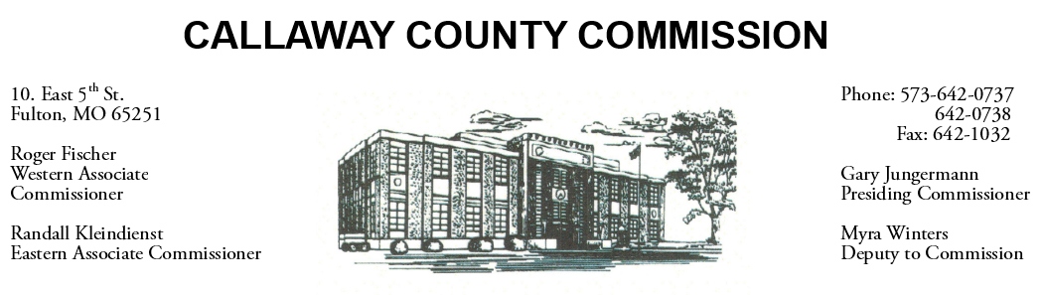

February 14, 2020
Friday
Tentative Agenda

- The Callaway County Commission will attend CCAM training at the Holiday Inn Executive Center in Columbia, MO …………………………………… 10:00 a.m.
- Presiding Commissioner Gary Jungermann may meet with the Tri-county group in Jefferson City, MO …………………………………………….……… 12:00 p.m.

Discuss and possibly sign purchase orders and requisitions submitted by elected
officials. Sign off on previous meeting minutes. The above meetings will be held
in the Commission Chambers, Courthouse, Fulton, Mo

(Unless otherwise stated)

Notice posted: 02/13/20___at_08:30 a.m.

