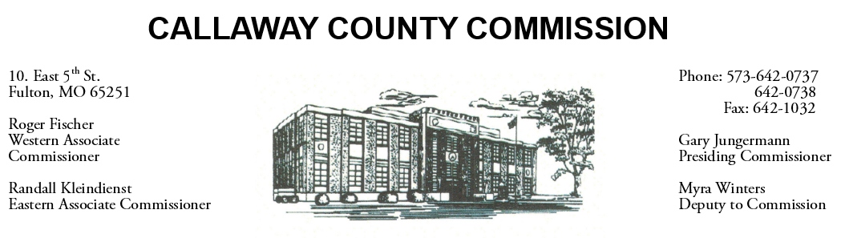

February 17, 2020
Monday
Tentative Agenda

- The Callaway County Courthouse will be closed in observance of President’s Day.
- The Callaway County Commission may attend the Auxvasse Lions Club 60th Annual Loafer’s week ………………………………………………… 8:00 a.m.

February 18, 2020
Tuesday
Tentative Agenda

- The Callaway County Commission will conduct business of a general nature.
- The Callaway County Commission may attend the Auxvasse Lions Club 60th Annual Loafer’s week ………………………………………………… 8:00 a.m.
- Western District Commissioner Roger Fischer will attend a port meeting in Jefferson City, MO ……………………………..……………………. 10:30 a.m.

Discuss and possibly sign purchase orders and requisitions submitted by elected
officials. Sign off on previous meeting minutes. The above meetings will be held
in the Commission Chambers, Courthouse, Fulton, Mo

(Unless otherwise stated)

Notice posted: 02/14/20___at_08:30 a.m.

