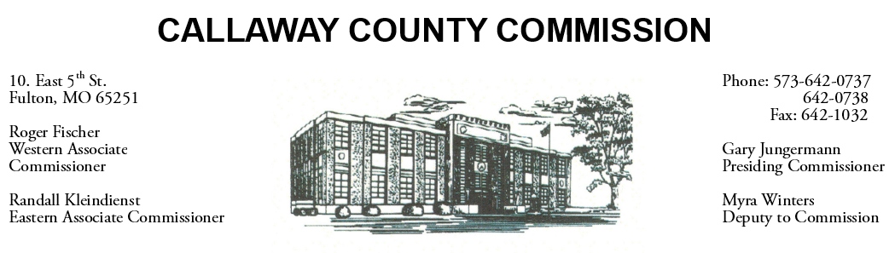
May 25, 2020
Monday
Tentative Agenda

- The Callaway County Courthouse will be closed in observance of Memorial Day.

May 26, 2020
Tuesday
Tentative Agenda

- The Callaway County Commission will conduct business of a general nature.
- The Callaway County Commission will meet to discuss Bid #15 Levee repair contract ……………………………………………………..….………… 8:45 a.m.
- The Callaway County Commission will meet to discuss a contract with Cochran Engineering ………………………………………………………………. 9:00 a.m.
- The Callaway County Commission will meet with Little Dixie Construction and N-Form Architect ………………………………………………..…………. 10:00 a.m.
- The Callaway County Commission will meet with HMN and Little Dixie Construction at the Callaway County EOC ………….…………………… 1:00 p.m.
- The Callaway County Commission may participate in a MAC conference call…………………………………………………………………………...3:00 p.m.

Discuss and possibly sign purchase orders and requisitions submitted by elected
officials. Sign off on previous meeting minutes. The above meetings will be held
in the Commission Chambers, Courthouse, Fulton, Mo

(Unless otherwise stated)

Notice posted: 05/22/20___at_08:30 a.m.

