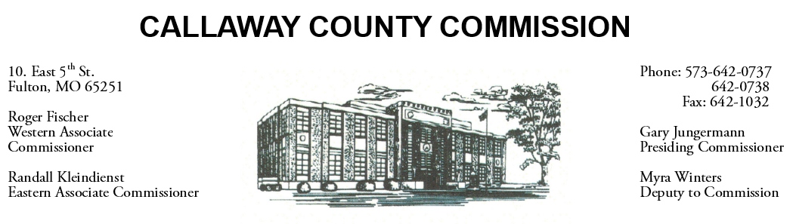

June 30, 2020
Tuesday
Tentative Agenda

- The Callaway County Commission will conduct business of a general nature.
- Western District Commissioner Roger Fischer will attend a United Way meeting in Jefferson City, MO ………………………………………….……………. 9:00 a.m.
- The Callaway County Commission may participate in a conference call with Little Dixie Construction ……………………………….…… ….. 10:00 a.m. Cancelled.
- The Callaway County Commission may attend a CARES Act meeting at the Callaway County Health Department meeting room ……………………….2:00 p.m.

Discuss and possibly sign purchase orders and requisitions submitted by elected
officials. Sign off on previous meeting minutes. The above meetings will be held
in the Commission Chambers, Courthouse, Fulton, Mo

(Unless otherwise stated)

Notice posted: 06/29/20___at_08:30 a.m. Changed 11:40 a.m.

