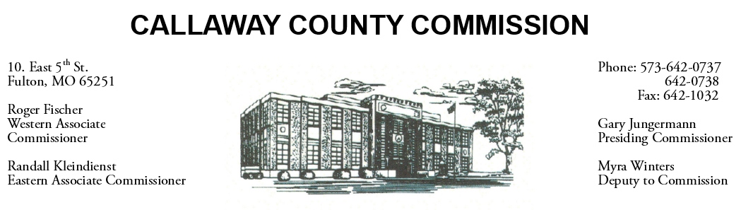

July 01, 2020
Wednesday
Tentative Agenda

- The Callaway County Commission will conduct business of a general nature.
- Presiding Commissioner Gary Jungermann may participate in a Zoom CARES Act hearing ………….………………………………………………………. 10:00 a.m.
- The Callaway County Commission will meet to open Bid #17 (Thermal Cameras -Callaway County Schools) ……………..……………………………….. 11:00 a.m.
- The Callaway County Commission will meet to discuss phase two of the CARES Act……………………………………………………………..………….11:30 a.m.

Discuss and possibly sign purchase orders and requisitions submitted by elected
officials. Sign off on previous meeting minutes. The above meetings will be held
in the Commission Chambers, Courthouse, Fulton, Mo

(Unless otherwise stated)

Notice posted: 06/30/20___at_08:30 a.m.

