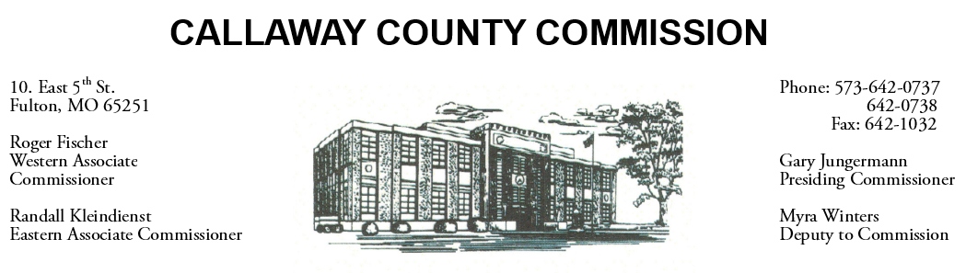

August 04, 2020
Tuesday
Tentative Agenda

- The Callaway County Commission will conduct business of a general nature.
- The Callaway County Commission may participate in a Callaway Chamber of Commerce conference call ………………………………………………. 9:00 a.m.
- The Callaway County Commission participate in a conference call with Little Dixie Contraction and will meet with Jennifer Wilson of N-Form Architecture and MEP Engineering at various locations throughout the day……….. ……………10:00 a.m.
- Presiding Commissioner will participate in a conference call with the Callaway Chamber of Commerce ……………………………….…………………. 12:00 p.m.

Discuss and possibly sign purchase orders and requisitions submitted by elected
officials. Sign off on previous meeting minutes. The above meetings will be held
in the Commission Chambers, Courthouse, Fulton, Mo

(Unless otherwise stated)

Notice posted: 08/03/20___at_08:30 a.m.

