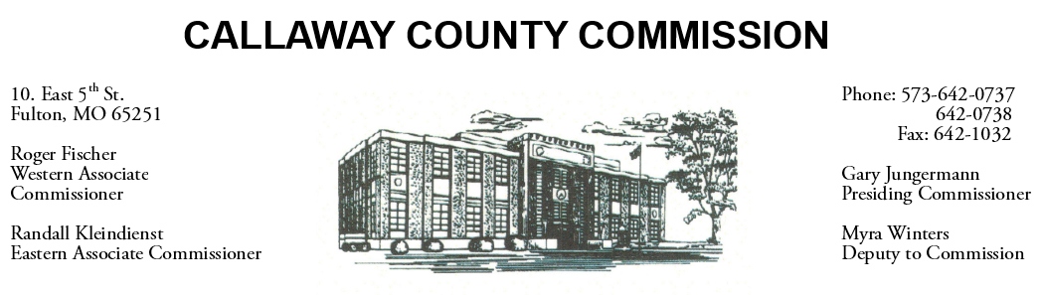

August 05, 2020
Wednesday
Tentative Agenda

- The Callaway County Commission will conduct business of a general nature.
- The Callaway County Commission will meet with HMN at the Law Enforcement Center throughout the day …………………….……………………… 10:00 a.m.
- The Callaway County Commission will meet with Westminster at Westminster College …………………………………………………….…………… 1:30 p.m.

Discuss and possibly sign purchase orders and requisitions submitted by elected
officials. Sign off on previous meeting minutes. The above meetings will be held
in the Commission Chambers, Courthouse, Fulton, Mo

(Unless otherwise stated)

Notice posted: 08/04/20___at_08:30 a.m.

