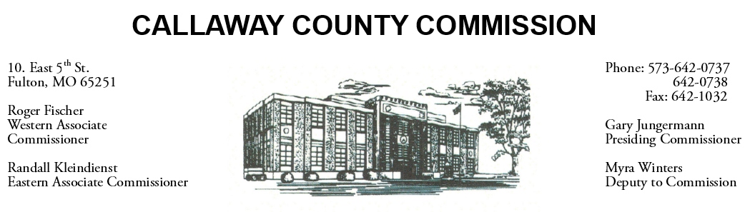
MEETINGS INVOLVING THE CALLAWAY COUNTY COMMISSION:
Meetings are held at the Callaway County Courthouse, Room G01, 10 East 5th Street, Fulton, MO unless otherwise noted.

Friday, October 23, 2020
Tentative Agenda

- The Callaway County Commission have budget discussions throughout the day.
- The Callaway County Commission may meet with Joe Fraizer to discuss a road vacation………………………………………………………………………..…………………………………….9:00 a.m.
- The Callaway County Commission will meet with Sheriff Clay Chism to discuss approval of 2021 Accurate Controls maintenance agreement, approval/acceptance of 2020 MO SHSP grant & approval/acceptance of 2020 federal BVP award ……………………..…………. 1:30 p.m.

The Callaway County Commission will conduct business of a general nature and other issues that may come before the Commission this day. The Callaway County Commission may meet with citizens, may meet with other elected officials, may meet with staff, may discuss and possibly sign purchase orders, payment requisitions, accounts payable reports, or previous meeting minutes throughout the day.

