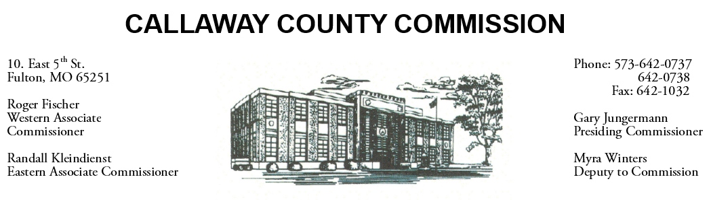
MEETINGS INVOLVING THE CALLAWAY COUNTY COMMISSION:
Meetings are held at the Callaway County Courthouse, Room G01, 10 East 5th Street, Fulton, MO unless otherwise noted.

Thursday, December 03, 2020
Tentative Agenda

- The Callaway County Commission have budget discussions throughout the day.
- The Callaway County Commission will have capital project discussions throughout the day.
- The Callaway County Commission will attend a pre-bid meeting at 54 Country…..10:00 a.m.

The Callaway County Commission will conduct business of a general nature and other issues that may come before the Commission this day. The Callaway County Commission may meet with citizens, may meet with other elected officials, may meet with staff, may discuss and possibly sign purchase orders, payment requisitions, accounts payable reports, or previous meeting minutes throughout the day.

