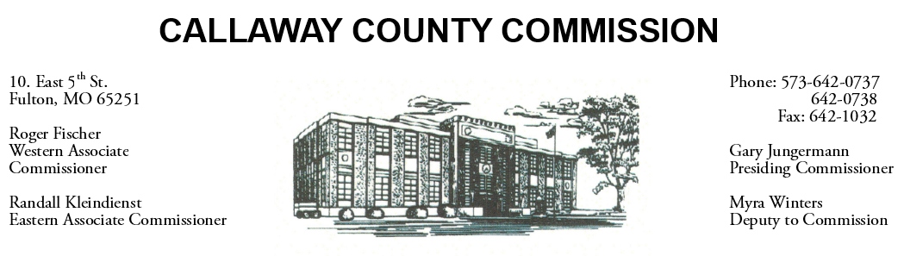
MEETINGS INVOLVING THE CALLAWAY COUNTY COMMISSION:
Meetings are held at the Callaway County Courthouse, Room G01, 10 East 5th Street, Fulton, MO unless otherwise noted.

Wednesday, December 02, 2020
Tentative Agenda

- The Callaway County Commission have budget discussions throughout the day.
- The Callaway County Commission will have capital project discussions throughout the day.
- The Callaway County Commission will meet to discuss the 2021 medical examiner agreement and a bulk mailing agreement with EJ Rice Co., Inc..…………………………. 9:00 a.m.
- The Callaway County Commission will meet to discuss the FADF agreement amendment …………………………………………………………………………………………………………..………………… 9:15 a.m.

The Callaway County Commission will conduct business of a general nature and other issues that may come before the Commission this day. The Callaway County Commission may meet with citizens, may meet with other elected officials, may meet with staff, may discuss and possibly sign purchase orders, payment requisitions, accounts payable reports, or previous meeting minutes throughout the day.

