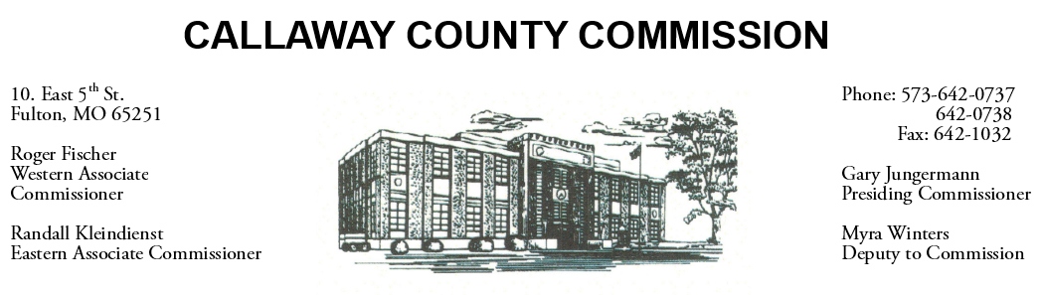
MEETINGS INVOLVING THE CALLAWAY COUNTY COMMISSION:
Meetings are held at the Callaway County Courthouse, Room G01, 10 East 5th Street, Fulton, MO unless otherwise noted.

Tuesday, June 15, 2021
Tentative Agenda

- The Callaway County Commission will have capital project discussions throughout the day.
- The Callaway County Commission will conduct business of a general nature.
- The Callaway County Commission may have CARES Act fund discussions throughout the day.
- The Callaway County Commission may meet with citizens, may meet with other elected officials, and may meet with various staff throughout the day.
- The Callaway County Commission may approve payment requisitions, approve accounts payable reports, or approve meeting minutes, or discuss and possibly sign purchase orders throughout the day.
- The Callaway County Commission will meet with Little Dixie at the Callaway County Jail construction site………………………………………………………………………..………………………. 9:00 a.m.
- The Callaway County Commission will meet with Ronda Miller, Callaway County Clerk at the Callaway County Health Department in Fulton, MO to discuss voting machines………………………………………………………………………………………………………….. 10:00 a.m.
- The Callaway County Commission will meet with Little Dixie Construction at the Callaway County Emergency Operations Center in Fulton, MO to discuss the Callaway County Justice Center……………………………………………………………………………………………………………….. 11:00 a.m.
- The Callaway County Commission will meet to discuss a contract with Cochran for the Callaway County Justice Center project……………………………………………….……………… 2:00 p.m.

The Callaway County Commission will conduct business of a general nature and other issues that may come before the Commission this day. The Callaway County Commission may meet with citizens, may meet with other elected officials, may meet with staff, may discuss and possibly sign purchase orders throughout the day. The Callaway County Commission may approve payment requisitions, approve accounts payable reports, or approve previous meeting minutes throughout the day.

