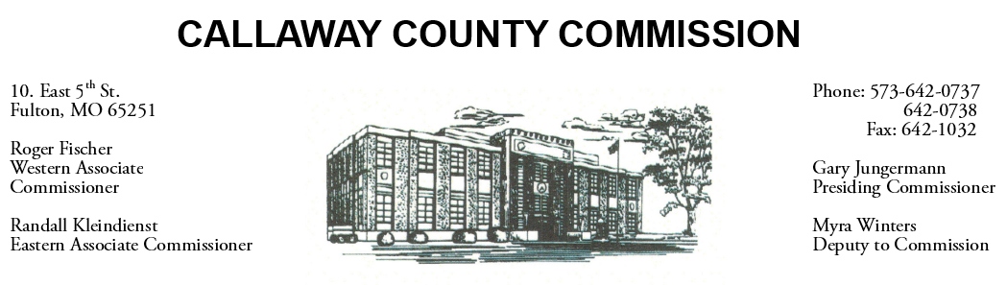
MEETINGS INVOLVING THE CALLAWAY COUNTY COMMISSION:
Meetings are held at the Callaway County Courthouse, Room G01, 10 East 5th Street, Fulton, MO unless otherwise noted.

Thursday, November 25, 2021 and Friday, November 26, 2021
Tentative Agenda

- The Callaway County Courthouse will be closed in observance of Thanksgiving.

Monday, November 29, 2021
Tentative Agenda

- The Callaway County Commission will have budget discussions throughout the day.
- The Callaway County Commission will have capital project discussions and meetings throughout the day.
- The Callaway County Commission will conduct business of a general nature.
- The Callaway County Commission will have ARPA fund discussions and meetings throughout the day.
- The Callaway County Commission will meet with citizens, other elected officials, and various staff throughout the day.
- The Callaway County Commission will approve payment requisitions, approve accounts payable reports, approve meeting minutes, discuss and sign purchase orders throughout the day.
- The Callaway County Commission will meet with the Callaway Sewer District and discuss ARPA funds ………………………………………………………………………………………………………… 8:30 a.m.
- The Callaway County Commission will attend a transportation meeting at the City of Fulton City Hall Building ……………………………………………………….………………………………………. 10:00 a.m.

The Callaway County Commission will conduct business of a general nature and other issues that may come before the Commission this day. The Callaway County Commission may meet with citizens, may meet with other elected officials, may meet with staff, may discuss and possibly sign purchase orders throughout the day. The Callaway County Commission may approve payment requisitions, approve accounts payable reports, or approve previous meeting minutes throughout the day.

