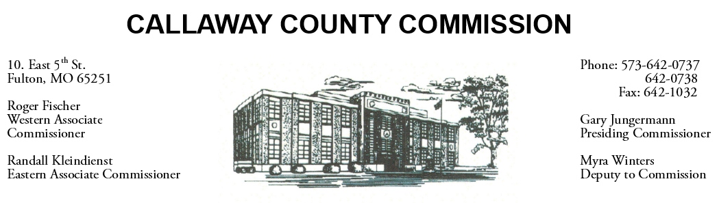
MEETINGS INVOLVING THE CALLAWAY COUNTY COMMISSION:
Meetings are held at the Callaway County Courthouse, Room G01, 10 East 5th Street, Fulton, MO unless otherwise noted.

Tuesday, May 17, 2022
Tentative Agenda

- The Callaway County Commission will have budget discussions throughout the day.
- The Callaway County Commission will have capital project discussions and meetings throughout the day.
- The Callaway County Commission will conduct business of a general nature.
- The Callaway County Commission will have ARPA fund discussions and meetings throughout the day.
- The Callaway County Commission will meet with Little Dixie Construction at the Callaway County Justice Center job site …………………………………………………..……………………. 10:30 a.m.
- Presiding Commissioner Gary Jungermann will attend an MMSWMD meeting at the MMSWMD office …………………………………………………………………..……………………….. 12:00 p.m.
- The Callaway County Commission will meet with Karen Rentschler, Callaway County Auditor to discuss a software repair quote from Zobrio ……………………………………… 3:30 p.m.
- Presiding Commissioner Gary Jungermann will attend an MU Extension council meeting at the MU Extension office in Fulton, MO ………………………………………..…………………….. 6:00 p.m.

On a daily basis, the Callaway County Commission will conduct business of a general nature and consider other issues that may come before the commission each day. The Callaway County Commission may meet with citizens, may meet with other elected officials, may meet with staff, and may discuss and possibly sign purchase orders throughout the day. The Callaway County Commission may approve payment requisitions, approve accounts payable reports, or approve previous meeting minutes throughout the day.

