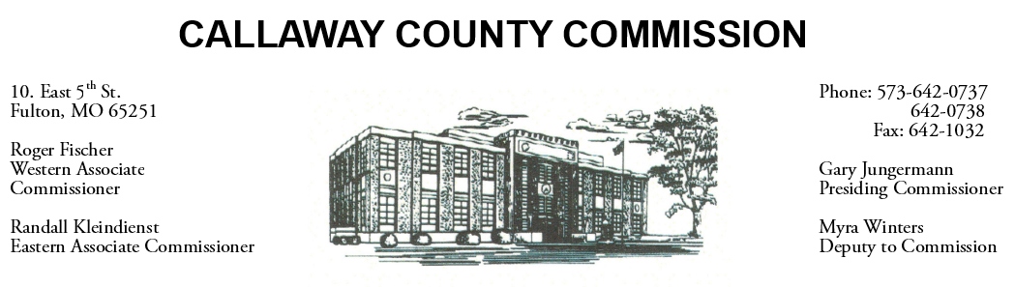
MEETINGS INVOLVING THE CALLAWAY COUNTY COMMISSION:
Unless otherwise noted, meetings are held at the Callaway County Courthouse, Room G01, 10 East 5th Street, Fulton, MO.

Thursday, December 01, 2022
Tentative Agenda

- The Callaway County Commission will have budget discussions throughout the day.
- The Callaway County Commission will have capital project discussions and meetings throughout the day.
- The Callaway County Commission will conduct business of a general nature.
- The Callaway County Commission will have ARPA fund discussions and meetings throughout the day.
- The Callaway County Commission will meet with citizens throughout the day.
- Presiding Commissioner Gary Jungermann will participate in an interview with University of Missouri Journalism students …………………………………………………………..……………..…………….. 9:00 a.m.
- The Callaway County Commission will meet with Clay Chism, Callaway County Sheriff to discuss the 2023 DPS ARPA Law Enforcement Grant application ………………………………………………………… 1:30 p.m.
- The Callaway County Commission will meet with MoDOT to discuss a roundabout in Holts Summit, MO……………………………………………………..…………………………………………………………… 4:00 p.m. – 6:00 p.m.

Daily, the Callaway County Commission will conduct business of a general nature and consider other issues that may come before the commission each day. The Callaway County Commission may meet with citizens, meet with other elected officials, meet with staff, and discuss and possibly sign purchase orders throughout the day. The Callaway County Commission may approve payment requisitions, approve accounts payable reports, or approve previous meeting minutes throughout the day.

