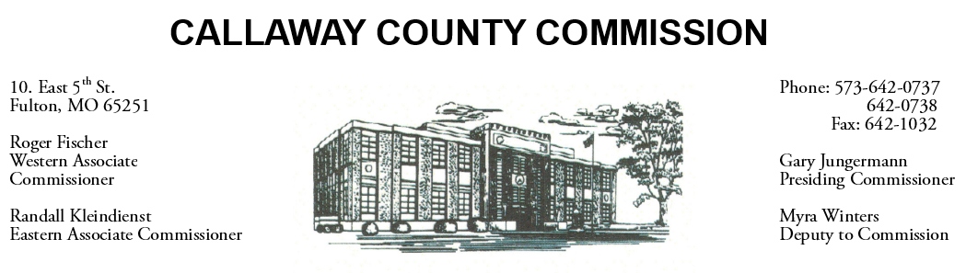
MEETINGS INVOLVING THE CALLAWAY COUNTY COMMISSION:
Unless otherwise noted, meetings are held at the Callaway County Courthouse, Room G01, 10 East 5th Street, Fulton, MO.

Friday, March 31, 2023
Tentative Agenda

- The Callaway County Commission will have budget discussions throughout the day.
- The Callaway County Commission will have capital project discussions and meetings throughout the day.
- The Callaway County Commission will conduct business of a general nature.
- The Callaway County Commission will have ARPA fund discussions and meetings throughout the day.
- The Callaway County Commission will meet with citizens throughout the day.
- The Callaway County Commission will have a monthly supervisor meeting with Paul Winkelmann, Callaway County Road and Bridge Engineer, at the Callaway County Road and Bridge office in Fulton, MO………………………………………………………………………………………………..………………………………….. 8:30 a.m.
- Presiding Commissioner Gary Jungermann will participate in a MAC Zoom meeting……….… 9:00 a.m.
- The Callaway County Commission will have a monthly supervisor meeting with Andrea Bedrosian, Callaway County Health Department Administrator, at the Callaway County Health Department in Fulton, MO………………………………………………………………………………………………….………………………9:00 a.m.
- The Callaway County Commission will have a monthly supervisor meeting with Michelle Kidwell, Callaway County Emergency Management Director, at the Callaway County Emergency Management office in Fulton, MO……………..…………………………………………………………………….. 10:00 a.m.

Daily, the Callaway County Commission will conduct business of a general nature and consider other issues that may come before the commission each day. The Callaway County Commission may meet with citizens, meet with other elected officials, meet with staff, and discuss and possibly sign purchase orders throughout the day. The Callaway County Commission may approve payment requisitions, approve accounts payable reports, or approve previous meeting minutes throughout the day.

